CRM GUIDE

Contents
1. Creating a New Contact 2
2. Linking a contact 4
3. High Needs and Suicidal Ideation 5

Creating a New Contact
  - Under ‘Contacts’ click ‘New’
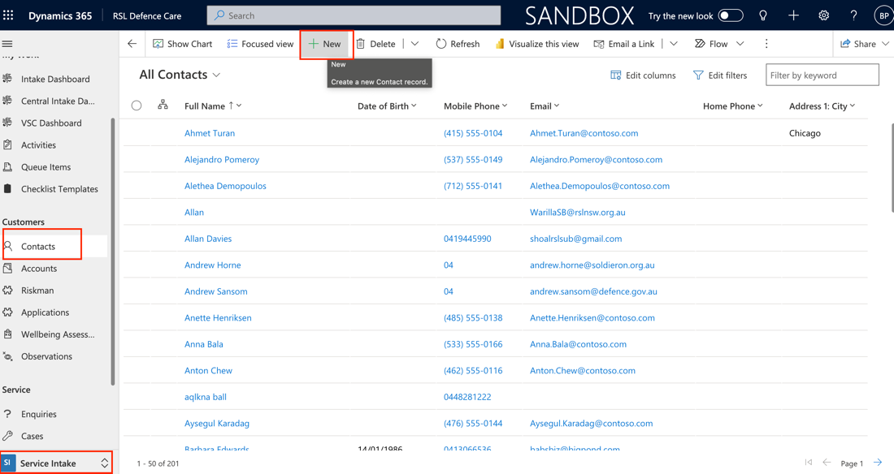
  - Enter client’s details.
    - Contact Information
      - First Name
      - Last Name
      - Email
      - Gender
      - Date of Birth
      - Mobile Phone
      - Aboriginal/Torres Strait Islander
      - Address (using the middle column of CRM)
    - Contact Type
    - Service
      - Status
      - Service
      - Enlistment
      - Discharge Date
      - Discharge Reason
      - Role
      - Deployment Summary
      - Discharge
    - Personal
      - Marital Status
      - Spouse/Partner Name
      - Children or dependent
      - Are children living with you
      - Culturally and Linguistically Diverse
    - PMKeys Number
    - Service Card and Pension
    - DVA Number

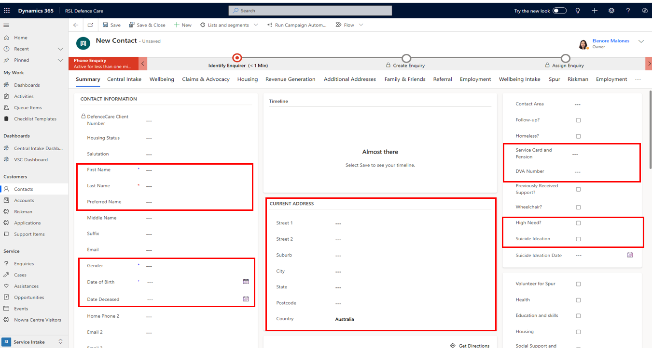
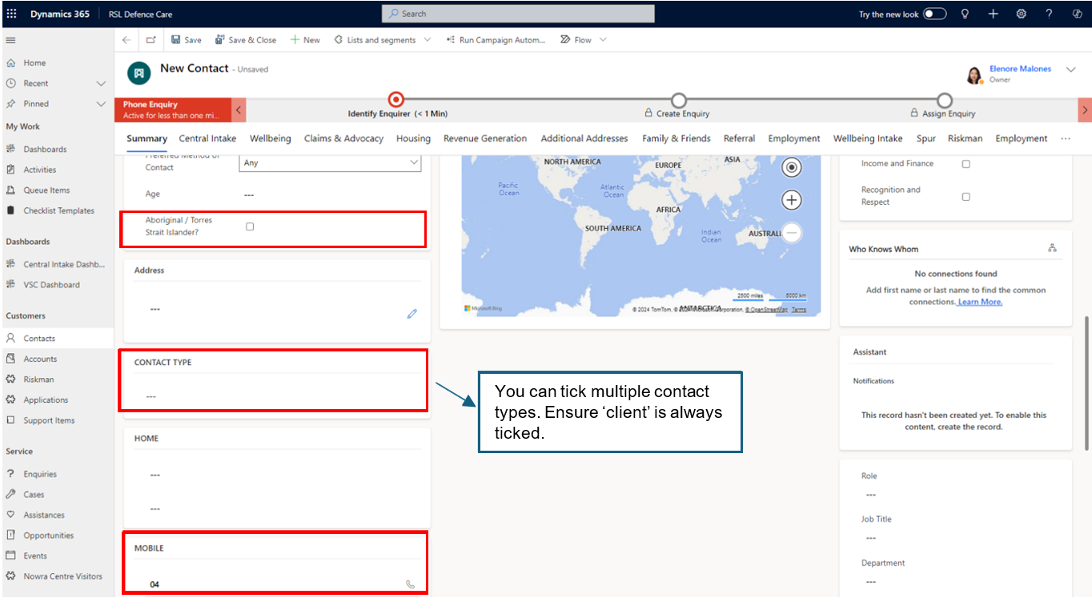

  - You may add any useful and relevant information under phone notes such preferred time to
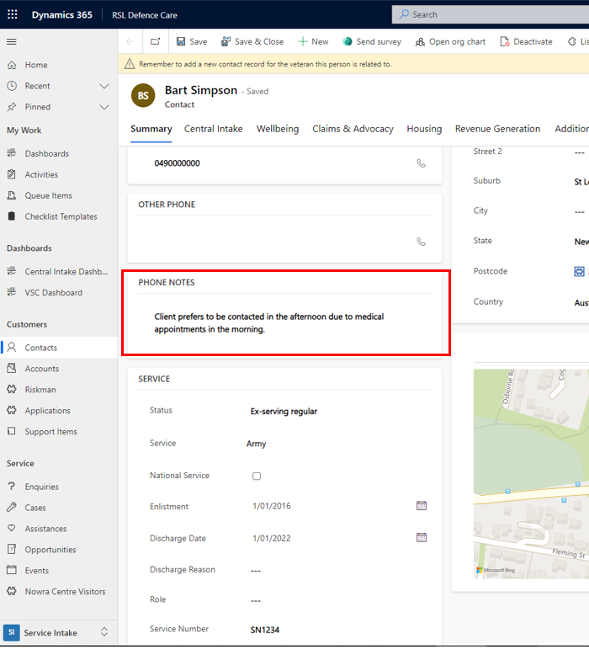

Linking a contact

Please note that to be able to link contacts, the veteran’s details will need to be entered and saved as a contact first before creating a contact for family members.

  - Click contact type
  - Tick ‘client’ and ‘relative’
  - Choose relationship type and enter veteran’s name in the box to start search
  - Click save when done
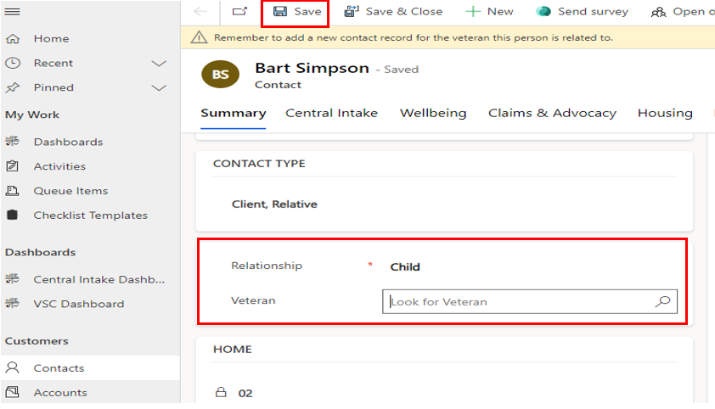

High Needs and Suicidal Ideation
  - If the client discloses previous suicidal ideation, tick the suicidal ideation box and add the date if possible.
  - Tick the ‘High Needs’ box if:
    - the client is experiencing multiple challenges that significantly affect their overall wellbeing and is receiving (or will require) additional support from other agencies.
    - there is significant information that might be useful for another staff member to know to fulfill their duties or when engaging with the client especially regarding staff safety.
  - In ‘Details’ box, you may add a brief note or description of the client’s complexity and/or useful information for other staff members.

When writing your notes:
- Always use respectful language
- Be objective and concise
- If unsure, consult with your manager and/or team
